Team232 Project Design

Part A: Supplementary information document

Xavier Andueza,

Ritchie Leong,

Ling Chen,

Kabir Chugh,

Jason Ung,

John,

# Executive Summary

Do after everything else has been written up.

Contents

1.0 Executive Summary 2

Contents 3

2.0 Introduction 4

3.0 Proof of Concept 5

3.1 Foam Detection Algorithm Summary 5

3.1.1 Background Removal 5

3.1.2 Bounding Box 5

3.1.3 Foam Detection Network 5

3.1.4 Information Extraction 5

4.0 Final Product Design 5

4.1 Expected End-Use Environment 5

4.2 Design Requirements 6

4.2.1 Hard Design Requirements 6

4.2.2 Soft Design Requirements 6

4.3 Overview of Final Product Design 7

4.4 Sub-assembly Analysis 7

5.0 Costings 7

# Introduction

Team 232’s innovative design is to be used for testing and diagnosis of digestate from an anaerobic digester (AD). It is intended to be portable, and carried around so that it can be screwed digestate release valves at customer sites.

The design is broken into three main sub-assemblies (SAs), being the:

* Hard plastic chassis, handle and rubber grip;
* Digestate container; and
* Electricals.

In creating the design, Team 232 has considered several hard and soft design requirements. The ways in which the requirements are met by the design are explored in this supplementary report. A part and purchase part list, with anticipated costs, notes and remarks are also included.

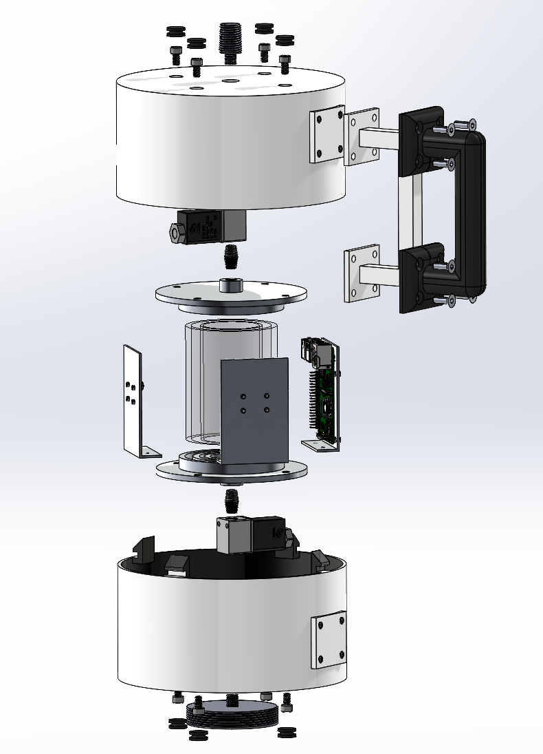

*Figure 4.3.1: Expanded Mechanical Components View*

# List of Design Requirements

All requirements were procured through market research performed by Monash University.

## Hard Requirements

The “Hard Requirements” are defined as the requirements that *must* be included in the design, and the design is considered insufficient without these.

| **Requirement** | **Specification** |
| --- | --- |
| Hold digestate for analysis | ≥100mL |
| Dry weight (no digestate) | <10kg |
| Instrument base area | <0.08m^2 |
| Hold electronics internally | - |
| Battery operated | - |
| Carry-friendly | - |
| No sharp corners | - |

## Soft Requirements

The “Soft Requirements” can be considered to be the factors that are considered by the target audience when making a purchase decision, but are typically not deal breakers to them. Team 232 assigned weighting factors to the Soft Requirements to establish a hierarchy of importance. This enabled the team to make better decisions when maximising one factor may come at the expense of another.

| **Requirement** | **Aim** | **Weighting Factor** |
| --- | --- | --- |
| Cost | Minimise | 5 |
| Weight | Minimise | 9 |
| Height | Minimise, but ensure comfortable handling | 8 |
| Surface Area | Minimise, but ensure comfortable handling | 8 |
| Aesthetics | Aesthetically appealing | 3 |
| Servicing Difficulty | Minimise | 5 |
| Amount of metal parts | Minimise | 5 |
| Manufacturing difficulty | Minimise | 5 |

# SA1: Hard Plastic Chassis, Handle and Rubber Grip Sub-Assembly

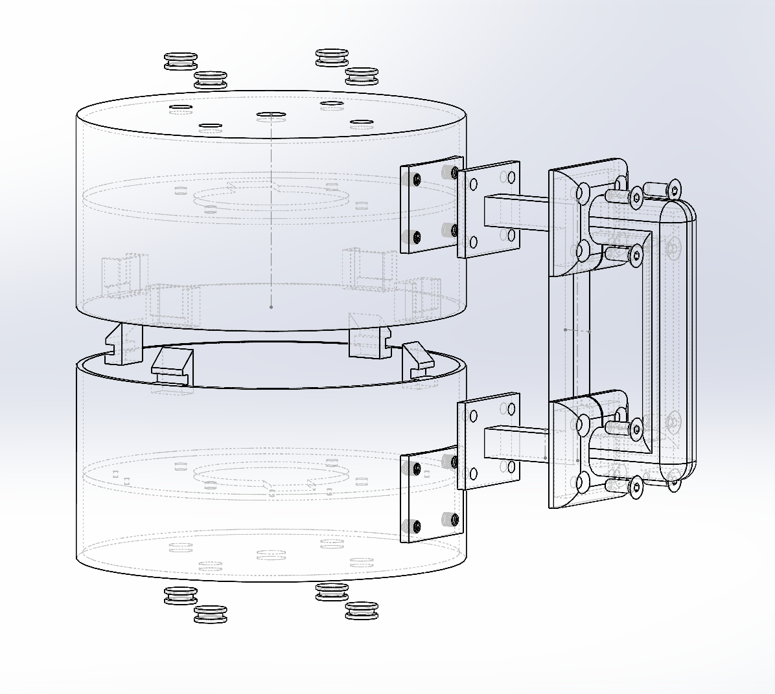

*Figure X: AAA*

## 4.1 Sub-Assembly Part List

Insert the part list

## 4.1 Hard Requirements Satisfied

Insert table and explanations

## 4.1 Soft Requirement Maximisation

Insert table and explanations

# SA2: Digestate Container

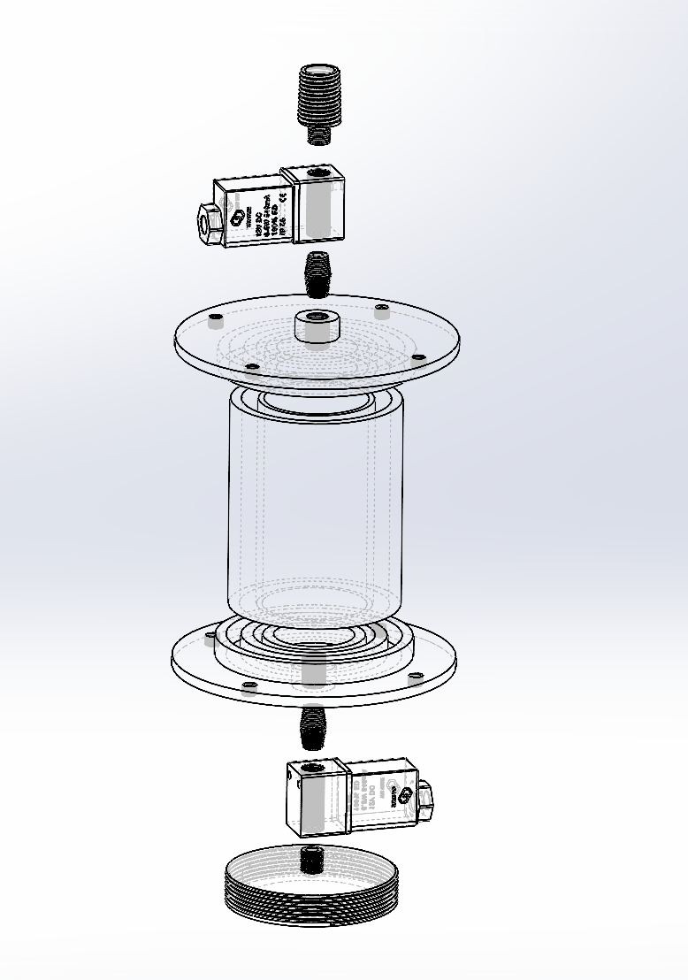

*Figure X: AAA*

## 4.1 Sub-Assembly Part List

Insert the part list

## 4.1 Hard Requirements Satisfied

Insert table and explanations

## 4.1 Soft Requirement Maximisation

Insert table and explanations

# SA3: Electricals

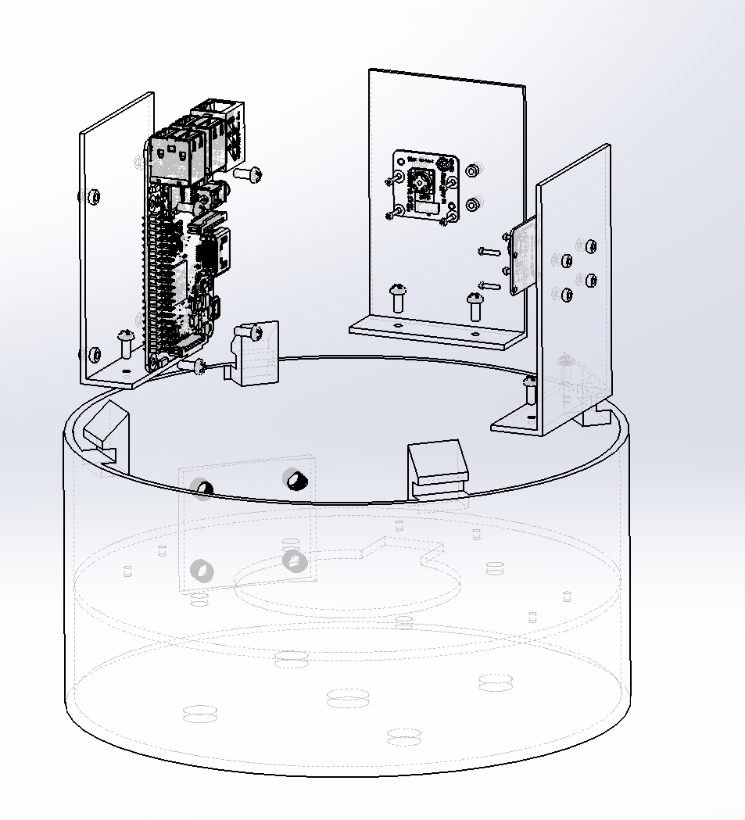

*Figure X: AAA*

## 4.1 Sub-Assembly Part List

Insert the part list

## 4.1 Hard Requirements Satisfied

Insert table and explanations

## 4.1 Soft Requirement Maximisation

Insert table and explanations

# 4.0 Final Product Design

## 4.1 Expected End-Use Environment

T232’s instrument's target audience is organisations that use ADs. These ADs will generally always be outside, and therefore the instrument will be exposed to a broad range of climates. The unit will be portable and will be taken closer to the ADs so that testing can be conducted. The unit may be transported and left in vehicles, which may expose the unit to even higher temperatures than the outside climate. Furthermore, T232’s Instrument may also experience significant shocks and vibrations at the customer sites, as users may accidentally drop the unit, or otherwise leave it unsecured in a vehicle as it travels bumpy roads. It is not anticipated that T232’s Instrument will be exposed to particularly detrimental electric shocks or electromagnetic interference.

Expected environments for the unit were defined as so:

*Table 4.1: Expected end-use environmental conditions*

| **Specification Type** | **Operational** | **Survival** |
| --- | --- | --- |
| Temperature | 0°C - 40°C | -20°C - 60°C |
| Humidity | 20-80% RH | 10-100% RH |
| Shock |  |  |
| Vibration |  |  |

## 4.2 Design Requirements

Design requirements were established by engaging with the target audience and understanding their perspective, as well as an analysis of the conditions in the end-use environment. They were broken down into Hard Specifications (the “must-haves”) and Soft Specifications (which are maximised against).

### 4.2.1 Hard Design Requirements

*Table 4.2.1: Hard Design Requirements*

| **Requirement** | **Specification** |
| --- | --- |
| Hold digestate for analysis | ≥100mL |
| Dry weight (no digestate) | <10kg |
| Instrument base area | <0.08m^2 |
| Hold electronics internally | - |
| Battery operated | - |
| Carry-friendly | - |
| No sharp corners | - |

### 4.2.2 Soft Design Requirements

Soft requirements were interpreted through a weighting factor. The higher the weighting factor the greater the design should factor this in.

*Table 4.2.2: Soft Design Requirements*

| **Requirement** | **Aim** | **Weighting Factor** |
| --- | --- | --- |
| Cost | Minimise | 5 |
| Weight | Minimise | 9 |
| Height | Minimise, but ensure comfortable handling | 8 |
| Surface Area | Minimise, but ensure comfortable handling | 8 |
| Aesthetics | Aesthetically appealing | 3 |
| Servicing Difficulty | Minimise | 5 |
| Amount of metal parts | Minimise | 5 |
| Manufacturing difficulty | Minimise | 5 |

## 4.4 Sub-assembly Analysis

* Break things down into the individual sub-components. Explain the design decisions that were made, what they maximised and how assembly will work. Give details to dimensions:
  + Fluid compartment sub-assembly
    - Expanded assembly view
    - Details of components, how they would be manufactured
    - Details of joiner (Araldite Temperature Cured solution)
  + Outer shell
    - Expanded view
    - Highlight intended manufacturing method, plastic molds
    - Highlight clipping (and how it can only clip in the one way)
    - Highlight how grip is secured
  + Electronics
    - Image of electronics secured down
    - Highlight how, where they are secured

# 5.0 Costings

Provide reasonable costings breakdown

*Table 5.1: Costing Summary*

| **Parts** | **Quantity** | **Cost ($) per unit** | **Source** |
| --- | --- | --- | --- |
|  |  |  |  |
|  |  |  |  |
|  |  |  |  |
|  |  |  |  |
|  |  |  |  |